Doubts, observations and concerns about the Vale Market website

- Nihan, here are the observations we have regarding the images of the products in the wholesale category so that you can please correct them:

  - Include the cheese subcategory within the delicatessen category
  - At the bottom of the page are the popular categories. Please remove the cheese category and include the following categories: Carniceria and Ventas al Mayor
  - Leche completa La Pastoreña:
    - Please correct the supplier of La Pastoreña milk, it says Covelac, and it is Convelac, C.A.
  - Please include the Mini Mortadela de Pollo in the delicatessen category, as it is missing, was removed.

    - Supplier: Valenmarket, C.A.
    - Brand: Rancheros
    - Presentation: Bolsa de 10 Kg aproximadamente
  - Mortadela de Pollo:
    - The photo you posted isn't correct. We're in the process of designing the packaging for this product, so it won't be sold for now. Can it be uploaded to the website without it appearing available for sale?
    - Supplier: Valenmarket, C.A.
    - Presentation: Bolsa de 12 piezas
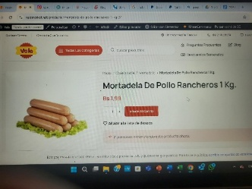

  - Papas Churros Parmark 1 kg:
    - Adjust the size of the photo, it is too big
  - Pollo Mis Pollitos
    - Change the image place the chicken in the bag of mis pollitos
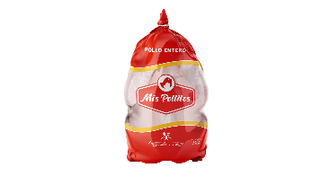
  - Refresco Fresh limon Glup 1 lt:
    - Presentation: Bulto con 12 unidades
  - Refresco Kolita Glup 1lt:
    - Change the product photo because the one shown is 400 ml and the product is 1 liter.
    - Presentation: Bulto con 12 unidades

  - In the mission paragraph where it says Buscamos llevar a cada hogar, include: o negocio.
  - Delete We work with the best partners and place: Marcas de Confianza detras de cada producto.
  - Delete: Quieres convertirte en nuestro socio? and place: Explora nuestras marcas (as title) and then below place the following text: Descubre la calidad que define a Vale. Te invitamos a explorar nuestra selección de marcas, cada una elegida cuidadosamente para ofrecerte una variedad inigualable de productos frescos, deliciosos y de excelente calidad. ¡Encuentra tus favoritas y llena tu carrito con lo mejor!
  - Add the logos of the brands we work with that are missing. I'll send you an email with those logos. (Flor de Arauca, LPrado, efes, Konfit, Pascual)
  - In the "About Us" section, where it says: "Bienvenido a Vale, tu supermercado integral¨. the text needs to be adjusted. It's cut off on the right side of the screen. The video is also missing; a black box appears.
  - In the paragraph where it says: Tanto si eres un cliente particular que busca la compra perfecta para tu hogar, como si eres un negocio que necesita abastecerse al mayor, temenos todo lo que necesitas. Please correct temenos by tenemos.
  - Please include a Login/Register tab. I know we discussed this a while ago and agreed that it wouldn't be mandatory, but Julio told me that this button must be there and that the customer must log in or register to make a purchase.
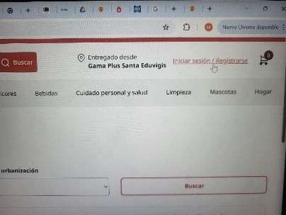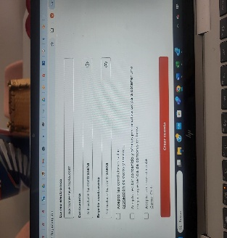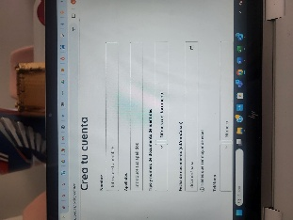

  - In the Carniceria category, remove the subcategory: Aves and Bobinos and add Pollo and Res. In the Chicken subcategory, include a photo of the bagged chicken from Pollos Rancheros. In the Beef subcategory, include a photo of the tenderloin, and in the Pork subcategory, include a photo of the smoked chop. Use photos of our products.
  - The boxes where the products go should all be the same size; some are larger than others. Please correct this.
  - Please remove photos of products we don't sell. In categories and subcategories, as well as on banners, place photos of the products you intend to sell, not of other brands.
  - Remove the menu and categories from the left side and place the menu at the top of the home page. Place the categories where the circles for 35% off energy drinks, new frozen vegetables, etc. are.

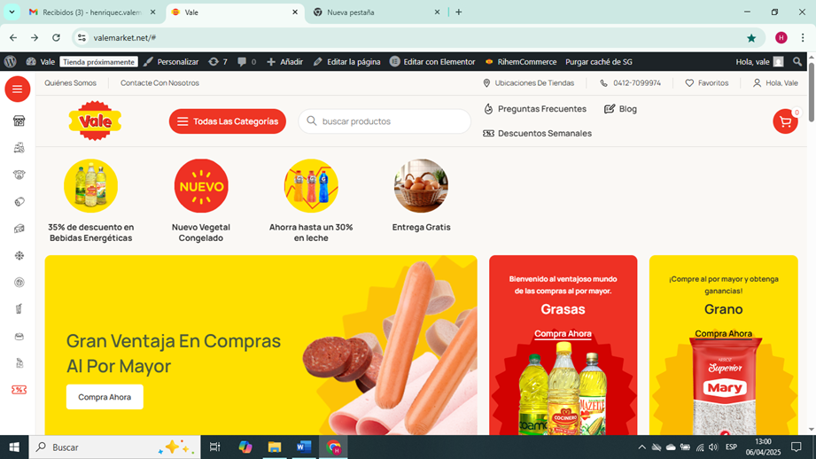
  - On the homepage, there should be a banner that refers to the benefits of wholesale sales. Clicking this button should display products with discounts for bulk purchases. It could be called: LOS MEJORES PRECIOS AL MAYOR, TU MAYOR DE VIVERES.
  - Upon entering, a pop-up window should appear to subscribe to the email with wholesale purchase offers
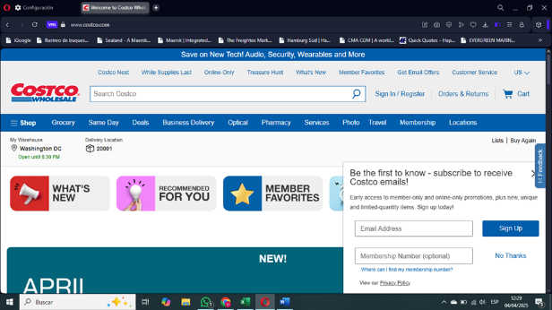

  - Check the responsive page at 100% size on the PC, the page appears cut off on the right
  - Where it says please change the text color to white because with the dark background you can't clearly see what the text says
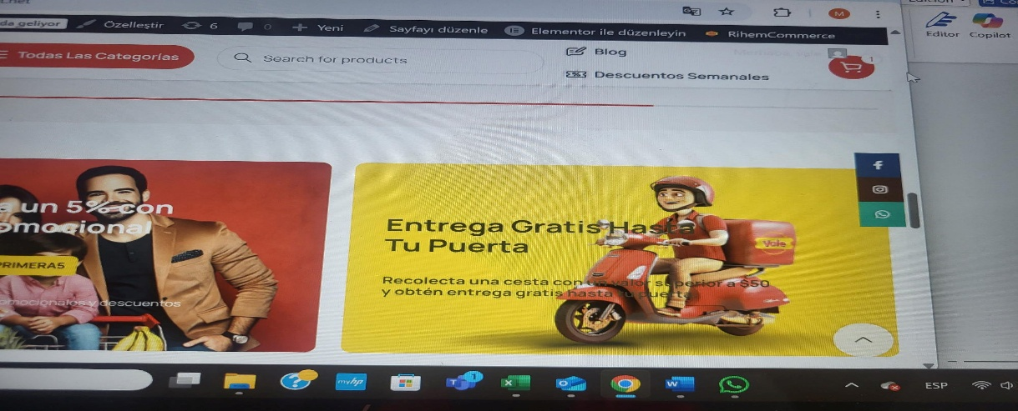

  - Please, remove the text from the banner that says: Welcome to the advantageous world of wholesale purchases and insert: Mientras mas compras mas ahorras. and remove the link click because it leads nowhere. You can also include only the image of mi coicnero oil. You can also include the box, and remove the Coamo and Mazeite oils.

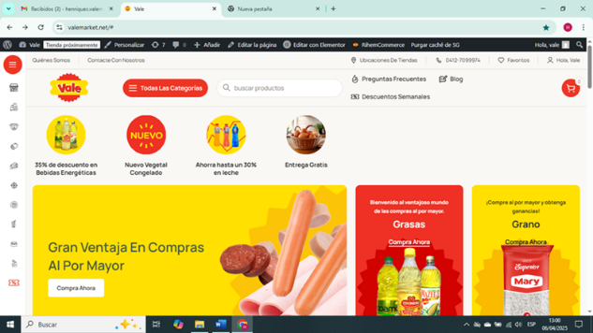
  - In the third banner that says buy wholesale and make a profit, delete that text and place: ¡Compra Online y Recibe tu pedido¡ And remove the link click because it leads nowhere.

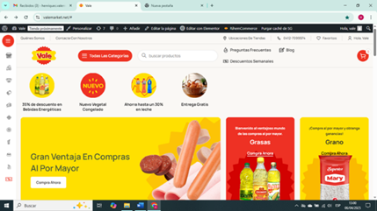

  - Please review the photos in the popular categories. In the butcher shop, place the bag of pollos rancheros. In the delicatessen, place the photo of the L. Prado ham we're using along with the hot dogs. In the grocery section, remove the Allegri pasta packaging and place one of the ones we're going to sell. In the beverage section, remove the Pepsi and Red Bull bottles since we won't be selling those products. Place another bottle of Glup, which could be the lemon one.
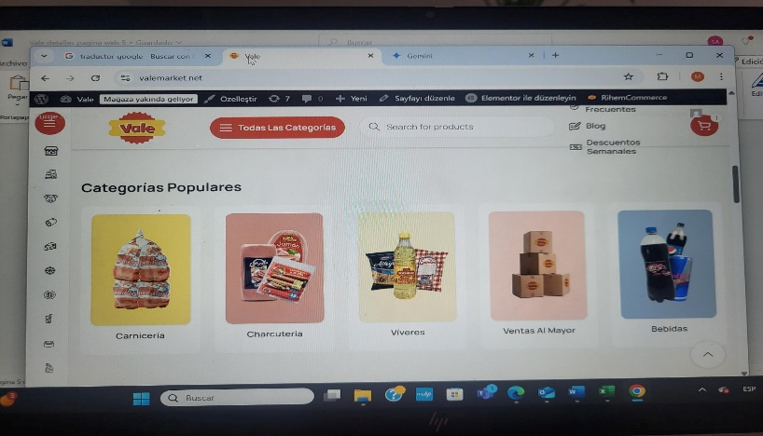
  - Where it says weekly discounts, it should say Descuentos por volumen. That button should show photos of the products with discounts, the discount percentage, and the final price.
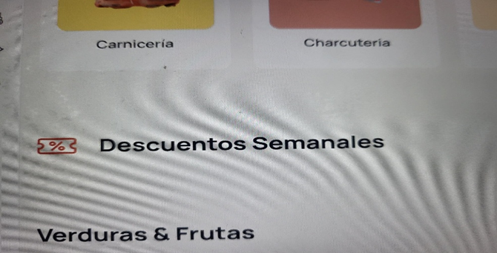

  - In the drinks category please correct where it says Alcoholico by: Bebidas con Alcohol y Bebidas Sin Alcohol
  - In the title Welcome to Vale Market your comprehensive digital supermarket correct and insert: Bienvenidos a Vale, tu tienda digital integral¡ 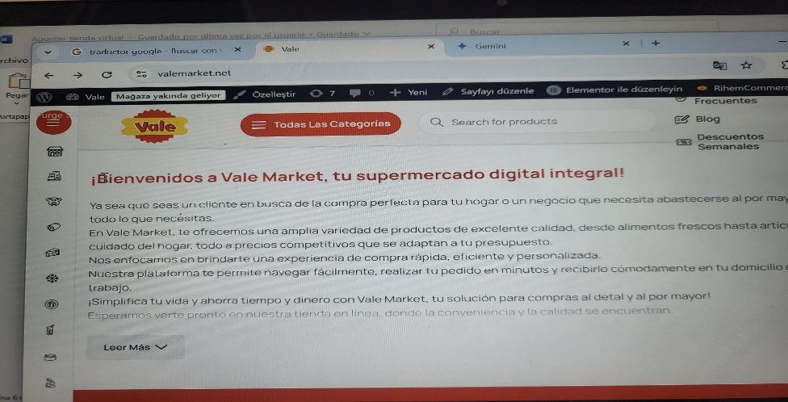

  - In this banner change the text: Gran ventajas en compras al por mayor and place: Tus compras al mayor a un clic de distancia. Check that the cart image looks pixelated and some design elements are missing.

